A Data-Driven Analysis of Player Performance and Compensation for Golden State Warriors in 2021-22 Season

ECO353H1-S: Special Topics with Data: Sports Economics
Data Analysis Project #2
Laura Turner

Luis Calderon (1009559693)
Taylan Gurpinar (1006989528)
Pratham Hemlani (1008170202)

Word Count: 1498
Introduction

The intersection between statistics and sports has created an environment where data-driven decisions significantly evaluate player performance and determine compensation. This project will utilize the Player Impact Plus-Minus (PIPM) method to analyze the on-court values of Golden State Warriors (GSW) players in the NBA. Data on player performance from 2021-22, their championship-winning season, was collected. Moreover, this investigation will aim to derive the Marginal Revenue Product (MRP) of each player in the team, calculated by applying the Scully method to player performance metrics. Comparing these values against player salaries will provide insights for team management and player contract negotiations. In doing so, the report will enhance the ability of various sports franchises to distinguish between player salaries and on-court performances. The results could alter their long-term evaluation strategies and optimize for better team performance.

Methods

In addition to using the PIPM method to calculate MRP with the regular season data, we also calculated the MRP for the playoffs season with playoffs data (2021-22 GSW Roster and Stats, n.d.; 2021-22 GSW Schedule, n.d.-a; 2021-22 GSW On/Off, n.d.-b). We added these two estimates to calculate the total player value over the entire season. To estimate the number of games, we used the number of games in the regular season and the number of games GSW played in the playoffs. We used annual CPI figures to calculate an inflation factor to adjust for the inflation between the model by Berri et al. based on 2011 and our calculation based on the 2021-22 season (Federal Reserve Bank of Minneapolis, n.d.). This inflation factor is found with the changes in CPI over the years. For the NBA minimum salary, we used the minimum wage for the 2021-22 season (Statista Research Department, 2024).

Results
Table 1.1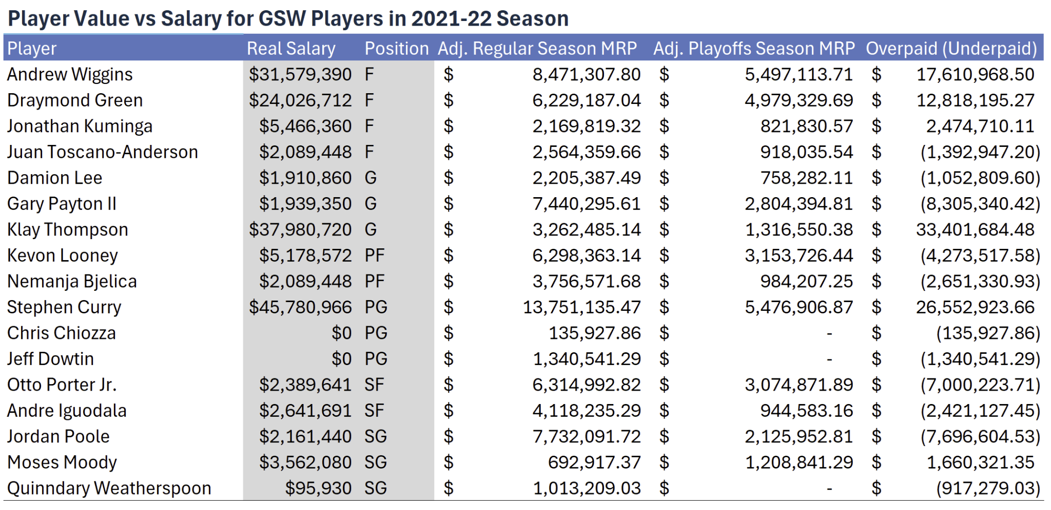Table 1.1 displays players' MRP found with the PIPM method. This method estimates the additional revenue a player brings to their team beyond what a replacement player would contribute. To measure it more accurately, we used the Adjusted Player MRP, the player's MRP adjusted for the discount rate, team performance (wins and losses, lagged), and NBA minimum salary for 2021-22. All of these factors are adjusted with the inflation factor. From the table, we can observe the following:
- With the highest listed salary of $45,780,966, Stephen Curry has significant regular season and playoff MRPs at $13,751,135 and $5,476,907, respectively. However, the data indicates he was overpaid by $26,552,924, suggesting that despite his substantial on-court contributions, they did not align with his earnings from a financial perspective.
- Klay Thompson's notable salary is $37,980,720, but his MRPs for the regular and playoff seasons are comparatively lower than Curry's, leading to an assessment that he was overpaid by $33,401,684. This disparity suggests that Thompson's financial impact, according to these metrics, was not in parity with his compensation.
- Andrew Wiggins and Draymond Green, with salaries exceeding $24 million, have MRPs that imply their financial contributions to the team are less than their salaries. The model categorizes Wiggins and Green as overpaid by $17,610,969 and $12,818,195 respectively.
- Conversely, with a relatively modest salary, Gary Payton II's MRP during the regular season exceeded his earnings, calculating that he was underpaid by $8,305,340. This indicates that he delivered remarkable value in relation to what he was paid.
- Players with smaller salaries, like Jordan Poole, Moses Moody, and Quinndary Weatherspoon, have MRPs that suggest they were underpaid, meaning they offer substantial value for each dollar. This indicates a high ROI for the team in terms of the value these players bring relative to their cost.

Discussion

As much as our model attempts to account for most of the measurable performance metrics available, several factors are not included in our calculations due to them being difficult to quantify, such as player’s off-court influence (popularity), future expectations for young players, bargaining power of different units, long-term contract limitations, overestimation of worker productivity and market competition. There are also limitations of the PIPM and MRP models, including but not limited to overlooking systematic biases for players in certain positions in calculations.

Player positions play a significant role in total compensation. Inspired by the revelation of Moneyball, several sports economists have searched and found evidence of systematic biases in player evaluations within basketball. Discovering that the NBA overpays players for points scored per game while underpays for efficient shot-making. Table 1.1 illustrates some insight regarding the systematic biases within the GSW payroll. As it appears, the GSW executives tend to undervalue the positions of Power Forward (PF), Point Guard (PG), Small Forward (SF), and Shooting Guard (SG). However, some outliers, including Stephen Curry (PG) and Klay Thompson (Guard), are overvalued. There also appears to be a tendency to overvalue players in the Forward (F) position, such as Andrew Wiggins and Draymond Green. The potential for systematic biases is not accounted for in our current model and may influence our estimates.

Another limitation of our current model revolves around the Scully method of player valuation. Calculating MRP in basketball requires several modelling assumptions to be met, including player interchangeability, statistical contribution to wins, and consistency of player performances. Furthermore, the status of basketball as a complex invasion sport may further add another layer of complexity to our calculations.

Consequently, GSW won the NBA championship in the 2022 season, which indicates that these statistics represent the players' peak performance. While the players deserve to get paid more for their outstanding performance this season, the salary figures on the player contracts are based mainly on past performance. These contracts do not always account for extreme circumstances, such as players having an outstanding performance and winning the NBA championship. This is an essential reason behind the higher MRPs for most team players compared to their actual salaries.

Moreover, our model must consider that players may produce revenue for teams through channels other than wins. Certain players, such as Stephen Curry, are typically responsible for generating revenues without or in addition to generating wins. An example of this is his strong personal brand. The strength of the individual brand and players' marketability also significantly impacts revenue for the team, as having a very famous player on the roster increases the size of the fanbase and viewership and drives sales of tickets and merchandise. These famous players are also attractive to firms doing endorsement deals, which can bring extra revenue to the team over time and should be accounted for in player value. Overall, they create significant additional value for the team's franchise that is not accounted for in the wins.

In addition, teams see potential in some young, rising star players who have yet to have a proven record of success but are expected to be better as they progress in the league. Some examples of this can be seen with Giannis Antetokounmpo and Jayson Tatum securing 5-year contracts worth 334 million dollars. The teams try to ensure “supermax” players with the expectation that they will potentially be better in the future (McGregor, 2023). This factor is not accounted for in the model as it is not explicitly reflected in the player statistics.
Furthermore, one factor that determines players' salary is their bargaining power. The possibility of being a free agent raises the player’s bargaining power to a reserve clause system since multiple teams can simultaneously compete to acquire one player. On the one hand, although, based on economics, employees would never be overpaid, the player’s options and the team competition determine a higher salary than he deserves. On the other hand, while no economic rule prevents workers from being underpaid, the presence of the National Basketball Association Union and the market competitiveness for signing NBA players make this scenario unlikely. We finally discussed the additional potential reasons for NBA players being overpaid, including the overestimation of workers' productivity due to insufficient information about the player (e.g. young prospects). Finally, the sports franchise and player enter into a long-term agreement where the employee's MRP varies, leading to periods where they are underpaid and periods where they are overpaid.

Conclusion

After all, our findings suggest a significant variance between the actual salaries and calculated MRPs of the players, indicating a misalignment in player compensation. Except for certain key players in the team, most players are undervalued. One of the biggest reasons behind this is the season we analyzed: the GSW’s last championship. Notably, Stephen Curry and Klay Thompson are observed to be overpaid, while players with lower salaries, like Gary Payton II, offer high returns on investment. These discrepancies highlight the complexity of these calculations and the fact that we need to incorporate more factors like marketability and the overall financial impact of players to refine and perfect our player value estimations better. As the NBA evolves, utilizing a broader range of metrics will be crucial for teams to have a competitive stance in the league.

Appendix

Figure 1.1: Pie Chart of Real Salary
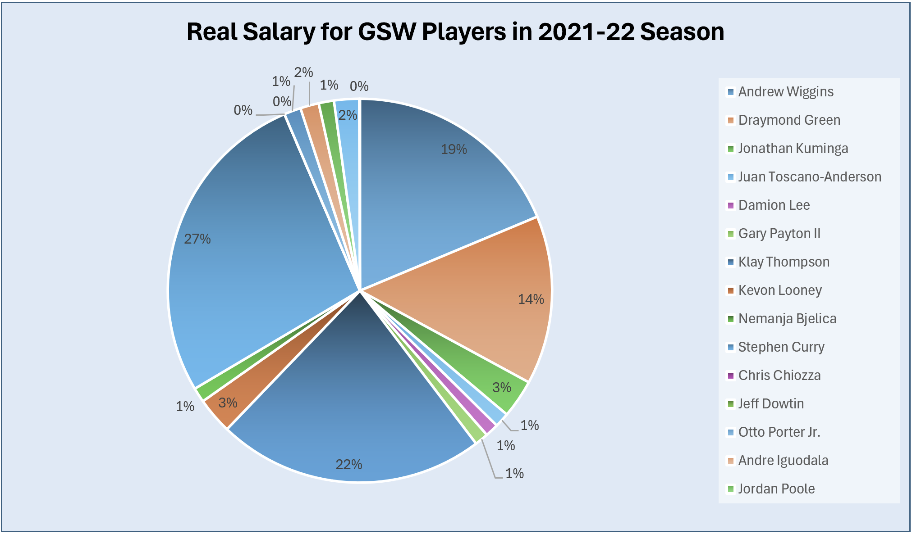

Figure 1.2: Bar Chart of Difference Between Real Salary and Calculated MRPs
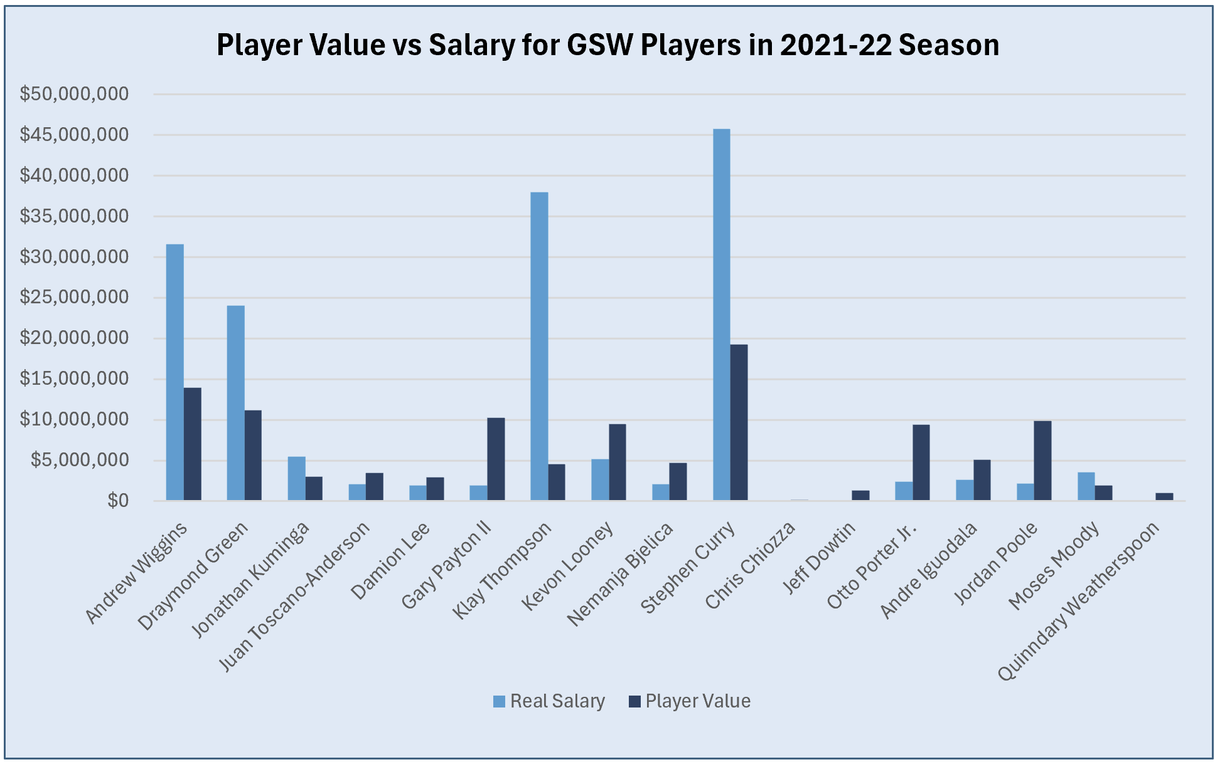
References

2021-22 Golden State Warriors Roster and Stats. Basketball. (n.d.). https://www.basketball-reference.com/teams/GSW/2022.html
2021-22 Golden State Warriors Schedule. Basketball. (n.d.-a). https://www.basketball-reference.com/teams/GSW/2022_games.html
2021-22 Golden State Warriors On/Off. Basketball. (n.d.-b). https://www.basketball-reference.com/teams/GSW/2022/on-off/
Consumer price index, 1913-. Federal Reserve Bank of Minneapolis. (n.d.). https://www.minneapolisfed.org/about-us/monetary-policy/inflation-calculator/consumer-price-index-1913-
McGregor, G. (2023, July 31). Potential Supermax contracts after Jaylen Brown’s historic deal: Giannis Antetokounmpo, Jayson Tatum Top list. Sporting News. https://www.sportingnews.com/us/nba/news/potential-supermax-contracts-list-jaylen-brown-tatum-giannis/xhjcn7qdkqcgzrfjo2elgsgk
Published by Statista Research Department, & 13, F. (2024, February 13). Minimum NBA salary 2017 to 2024. Statista. https://www.statista.com/statistics/1009569/minimum-nba-salary/

